TLA Privy Boxes Design and Instructions
MATERIALS:

Front/Back – | Sides – | Seat – | Lid –
4 x 31”(1x6) | 4 x 22”(1x6) | 4 x 32”(TG cedar) | 4 x 32”(TG cedar)
1 x 27”(2x2) | 1 x 22”(2x2) | 4 x 18”(2x2) | 1 x 32”(2x4)
2 x 20”(2x2) | 2 x 20”(2x2) |  | 2 x 17½”(2x4)

TOTALS:
2 x 2 – | 1 x 6 – | 2 x 4 –
2 x 27" | 8 x 31" | 1 x 32"
2 x 22" | 8 x 22" | 2 x 17½"
8 x 20" | 8 x 32"
4 x 18"
Note that PRESSURE-TREATED 1 x 6 may be substituted for TG cedar (less expensive)
2” nails and 1¼” screws required for assembly
Also, two hinges; one 12” piece of chain and two lag bolts with washers to hold lid upright when open

ASSEMBLY:
*NOTE: When insets are described, the measurement is from the end of the board that will be exposed, to the OUTER edge of the support frame.*
- Cut all pieces to appropriate dimensions.
- Assemble the left and right sides by placing the 22” 1x6 pieces side by side. Place the support frame of 2x2 pieces on top, as shown in the images. The 22” piece goes along the top, parallel to the boards and the 20” pieces are placed perpendicular to the 22” piece, along the sides. All sides of the support frame should be flush with the outer structure.
- Drive one nail through the 22” support and one nail PER BOARD for the shorter supports (4 nails on each 20” piece). Flip the sides over, and then drive two more nails PER BOARD through the 1x6 pieces and into the 2x2 supports. The entire side should have 18-20 nails on the outer face. (Placement of the two marked nails determines the nails required. Aim for the corners, in order to nail into the top support rather than the sides for these two.)
- Assemble the front and back in the same manner, but the two side supports (20” 2x2 pieces) are set in from the ends of the top support by 2”. Keep in mind that the longer support piece is 27” for the front and back of the box, rather than the shorter 22” piece used for the left and right. The number of nails required for assembly should likewise remain the same.
- Once all four sides have been prepared, dry-fit the box. Put screws into the front and back sides, which will grip into the side of the 2x2 supports to hold the box together. Use 2 screws PER BOARD, for a total of 8 screws at each of the four corners.
- The last faces of the box to be built are the seat and lid. Each is assembled in much the same way as the four sides, except for changes in measurements. The lid is very similar to the sides, with the same shape of the support structure to be used. These supports are 2x4 boards cut to the proper length, but otherwise the assembly is exactly the same. The number of nails used is likewise the same.
- The seat is a little different in design, as it will eventually have a hole cut into it (use a jigsaw) and it will need to support the weight of a range of campers. Lay down the 1x6 pieces as before, but the 18” supports are all perpendicular in orientation. The outer supports are set in 3½” from the edge, and the inner supports are set in 10”.
- Once the seat has been assembled, use screws to attach it to the box. Use two screws PER BOARD, except on the last one at the back (the hinge will be attached here) – that board gets one screw to leave space for the hinge. Thus, the top is attached with a total of 14 screws.
- Once the box is assembled, attach the lid to the seat with 2 hinges – each requires 6 screws. The hinges are to be placed in such a way that the connecting bolt is just off the seat and lid, making the flat piece of metal flush with the edge of each.
- After attaching the hinge, use 2 lag bolts with washers to attach the length of chain to the side of the lid and the side of the seat, preventing the lid from opening past 90°.
HINT: It is easiest to attach the chain by keeping the lid closed while screwing in the first bolt, then opening as far as intended to place the bolt, turning a couple times, and closing the lid once again to reduce tension while working.
- The final step is to cut an oval hole in the privy seat using a jigsaw and the given template. It may be necessary to use a knife or something similar to start the hole before inserting the jigsaw to start cutting. Don’t forget to sand the area once the hole has been cut out. Staple a TLA privy sign to the inside of the lid (a photocopy is attached), and the privy box is complete.
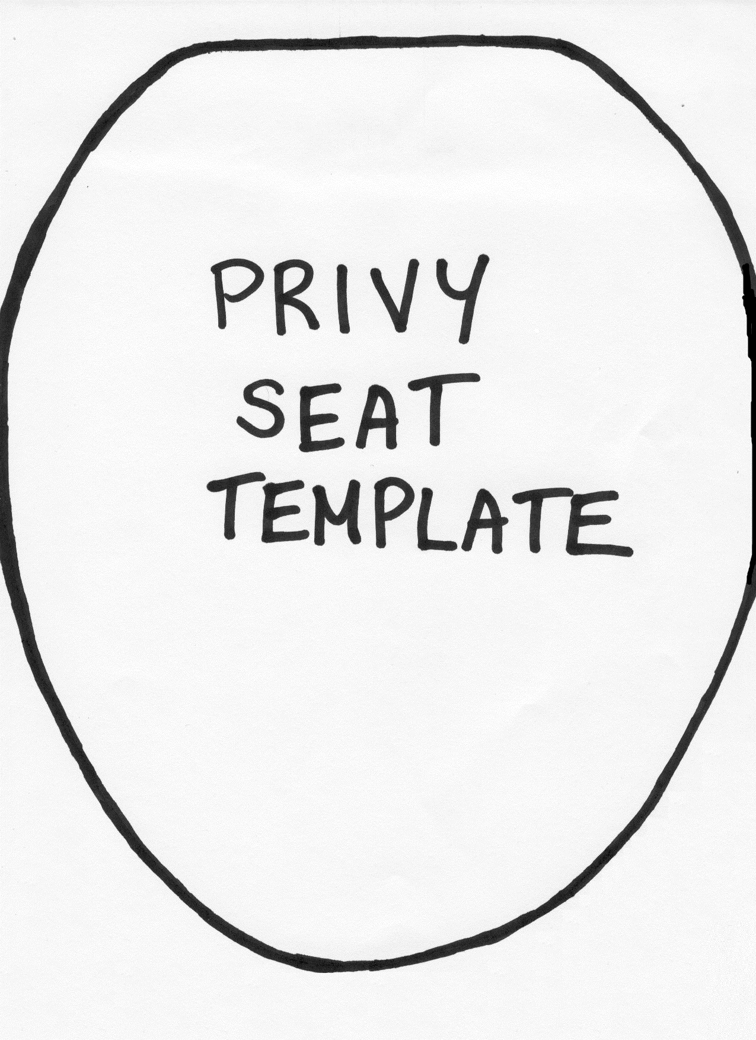
  - Interior Campsite Pit Privy Box – Location and Installation Notes

Location
- at least 60 metres from water sources (e.g. lake shore, rivers, creeks) to prevent water contamination
- at least 60 metres from campsite, portages, or other trails to prevent contamination and for privacy
- vegetation cover for screening/privacy
- soil depth—1 metre minimum; consider also future hole relocations in same area

Trail Construction
- curve the trail, with a “J” shape near the end to enhance privacy
- privy should be installed so that moving the privy at a future date does not encourage travel over recently filled holes
- prune a small area around the privy to allow for air circulation

Box Installation
- Depth: dig hole approximately 1 to 1½ metres deep
- Diameter: not too large to undermine privy foundation
- Orient privy box so that when lid is up, the back faces the trail for further privacy—also don’t forget to keep in mind scenic views from the “throne”!
- Anchor box to soil using two cedar poles or pressure-treated wood; box is secured to inside of poles with spikes. Notch poles to fit box as required (e.g. if using round cedar logs)
- ensure pole ends are buried into soil to stabilize the entire structure
- ensure area around box is sloped away so water will not drain into the pit

Trail Signage
- place one marker (blue diamond) near beginning of trail visible from campsite; use additional marker(s) only as necessary along trail length
- place markers approx. 2 metres high (slightly higher than eye level) to help reduce vandalism or theft
- Use galvanized roofing nails in top and bottom holes. NOTE: leave ± ½” space between nail head and tree to allow for future tree growth

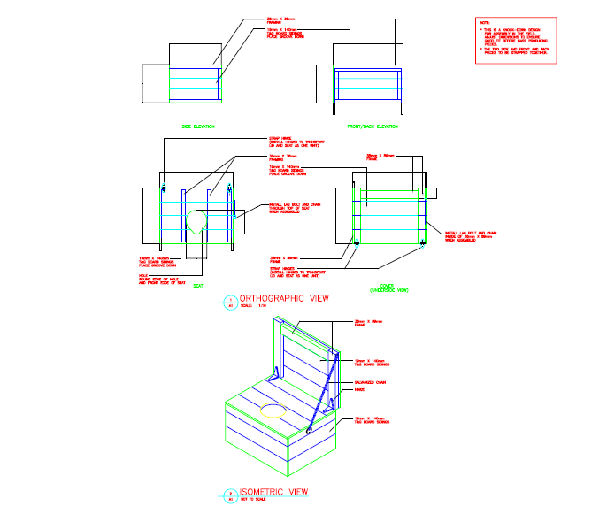
Inside the box, showing support frames (front face to bottom of page)
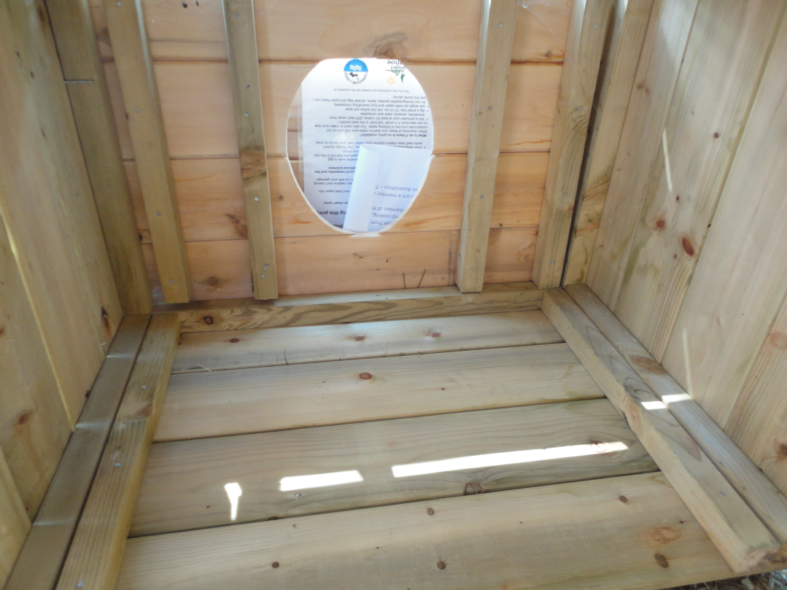
Outside view of completed box
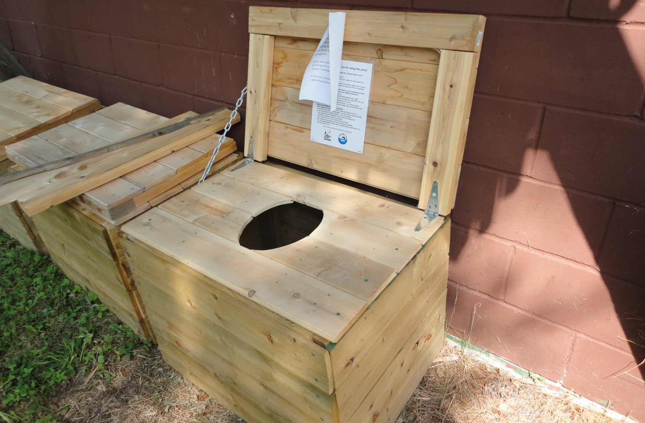

To replace seat and lid only (required on several campsites – carpenter ants – esp in NE arm):

Required materials –
8 x 32” (1x6)
1 x 32” (2x4)
2 x 17.5” (2x4)
2 x 18” (2x2)

One 12” piece of chain, 2 lag bolts, 2 washers, and a multitude of nails or screws or both

Built as on previous pages

3 x 32” pieces may be made from a single 8’ board
5 x 17.5” pieces may be made from a single 8’ board
5 x 18” pieces may be made from a single 8’ board

Therefore, each lid set requires:

3 1x6 (1 piece leftover), 1 2x4, 1 2x2

However, when making sets, a larger group may be more efficient due to cast off pieces.

